Mini How To:

Create And Setup A Google Group For Your Scout Troop
Joseph Lewis III

A Google group allows scouts, and parents to communicate with each other in a safe and controlled environment. Every email sent is archived, and therefore is viewable by adults should harassment issues arise. Files can be stored on the group, troop pictures, videos, workbooks, etc. And the group can be locked so only people from the troop can view these files, names and information, keeping everyone safe from the web. The best part about Google Groups is unlike Yahoo, everyone can sign up and view the group without needing their own Google email address.

This tutorial will show you how to set up your Google group, add users, remove users, and tune settings.

Part One Setting Up Your Group
1) The first thing you need to do is go to <http://groups.google.com>, this is where you will set up your group.
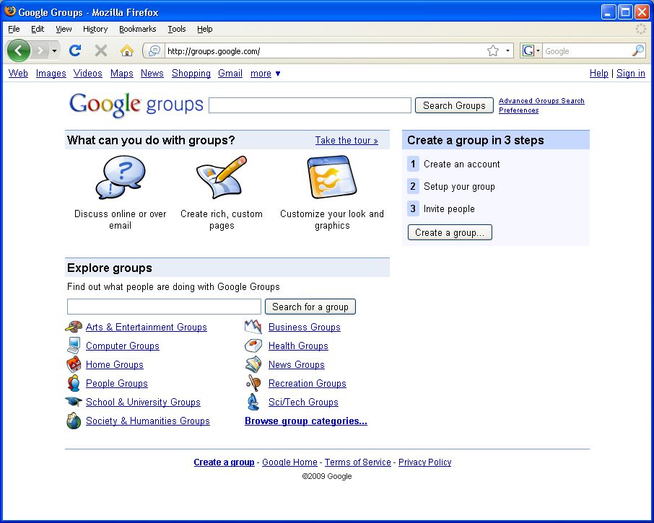
Press the button called “Create a group” it is outlined in red above.

- You are brought to a page that asks you to sign in to a Google account, If you have a Google account skip the next few steps.
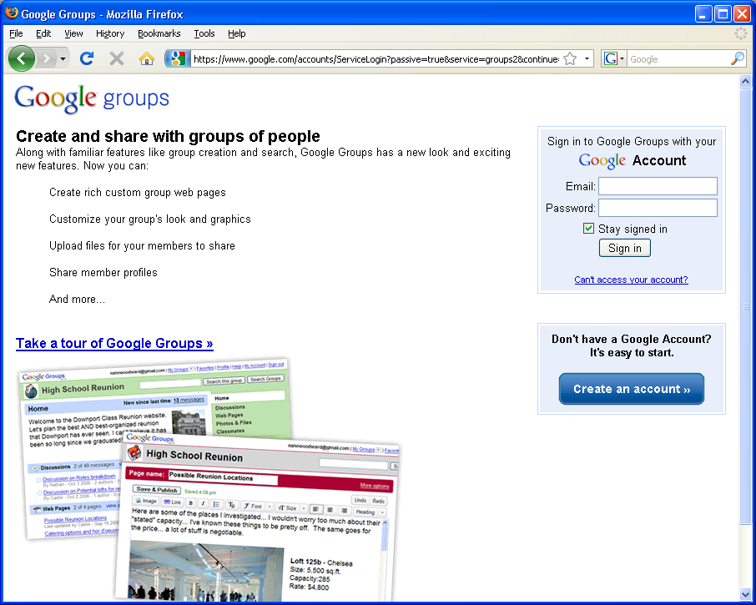
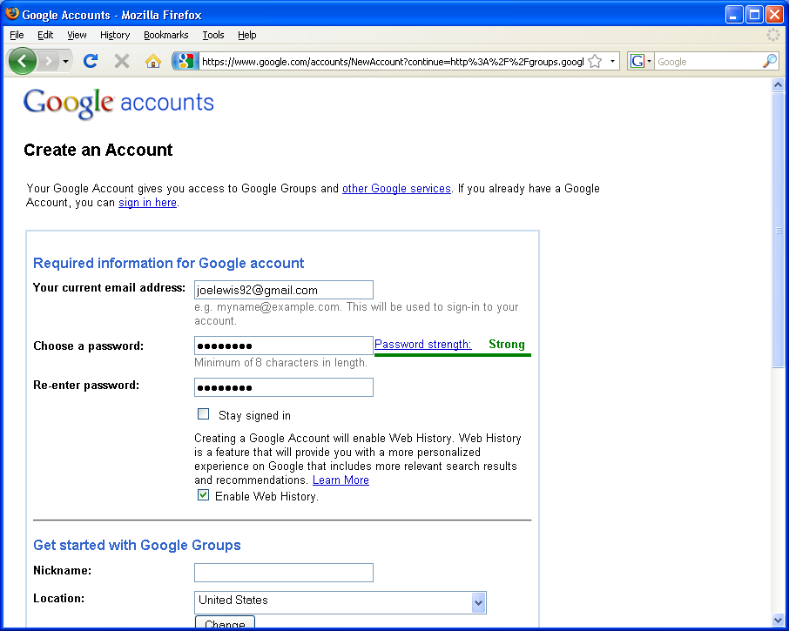
- Fill out the form. Un-check Stay Signed In
- Once you get finished you should get to a screen like the one below. If not go back to step one, and on step two sign-in to your account.
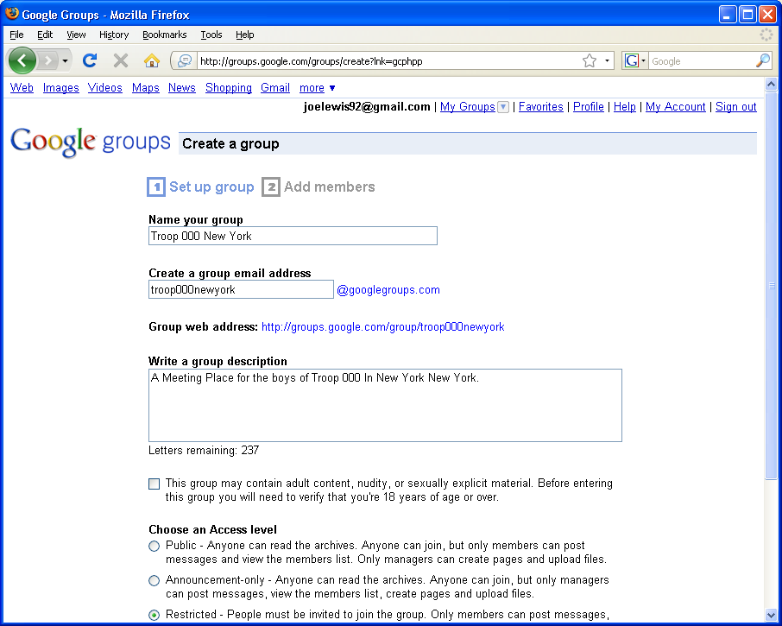
- Name Your Group something Simple, Like Troop 000 New York, try to avoid long names like boy-scouts-of-america-troop-000-new-york-new-york, it may say exactly what you want but people will despise typing it.
- Select Restricted as an access level, this makes sure your group is secure from outside eyes.
- Next Google will ask you to enter the letters as shown, you may fail a few times as Google ones are hard.
- After this you will be requested to enter the email addresses of people

